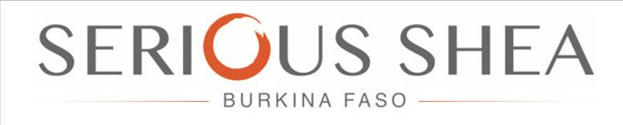

HUMAN RIGHTS POLICY

UPDATED MAY 2019

A. Introduction

Serious Shea expect to be held to high standards in all of its activities acting as a world-class nut aggregator, processor and marketing company and a good corporate. We care about the impact of our decisions, large and small, on those around us. This includes impacts on human rights.

B. Commitment

1. We conduct our business in a manner that respects the rights and dignity of all people, complying with all legal requirements.

2. We respect internationally-recognized human rights, as set out in the International Bill of Human Rights and the International Labour Organization’s Declaration on Fundamental Principles and Rights at Work.

3. We recognise our responsibility to respect human rights and avoid complicity in human rights abuses, as stated in the UN Guiding Principles on Business and Human Rights.

4. We treat everyone who works for Serious Shea fairly and without discrimination. Our full-time and part-time employees, users of our shea collection and processing facilities and members of our partner women’s groups are entitled to work in an environment and under conditions that respect their rights and dignity.

5. We respect freedom of association. Where our employees wish to be represented by trade unions or works councils, we will cooperate in good faith with the bodies that our employees collectively choose to represent them within the appropriate national legal frameworks.

6. We respect the rights of people in communities impacted by our activities. We will seek to identify adverse human rights impacts and take appropriate steps to avoid, minimize and/or mitigate them.

7. We will seek to make contractual commitments with suppliers and partners that encourage them to adhere to the same principles contained in this policy statement.

C. Delivery

1. We will meet our responsibility to respect human rights by implementing the relevant sections of the UN Guiding Principles on Business and Human Rights and incorporating them into the processes and policies that govern all our business activities.

2. We will work to embed human rights into environmental and social impact assessments as appropriate. In assessing and addressing the impacts of our operations and relationships, we will consult with those who may be affected, including indigenous peoples, where this is possible and appropriate, while meeting applicable legal requirements.

3. Where Serious Shea identifies that we have caused or directly contributed to adverse impacts on the human rights of others, Serious Shea shall provide for or cooperate in the remediation of the adverse impacts through legitimate processes.

4. We will continue to engage in human rights-related multi-stakeholder initiatives, including the Voluntary Principles on Security and Human Rights. We believe that multi-stakeholder efforts are an effective means of promoting reasonable standards for positive change in human rights practices at the operating level.

5. We will make sure that our communications with governments, regulatory bodies and public authorities are consistent with our human rights commitments, as stated in this policy.

6. In those instances where there is a conflict between a legal requirement and this Policy Statement, we shall seek to always apply the most stringent standard, as stipulated in the UN Guiding Principles on Business and Human Rights, without violating domestic law.

D. Governance

1. This Policy Statement applies to every employee and officer in Serious Shea including and any future joint ventures (JVs) to the extent possible and reasonable given Serious Shea’s level of participation. In situations where Serious Shea does not have overall control of an organisation, we will do everything we reasonably can to make sure our partners follow similar principles.

2. Serious Shea shall record and report internally all legitimate adverse human rights impacts, in line with this Policy Statement.

3. Serious Shea shall report to stakeholders on the implementation of the Policy Statement.

